Pack It Up Software Design Documents
Abel Lagonell
Nicholas Ciarlone
Samantha Odum
Table of Contents
Requirements 3
Use Case Diagram 4
Use Case Scenarios 5
Requirement Fulfillment Chart 6
Class Relation Diagram 7

Requirements

Use Case Diagram
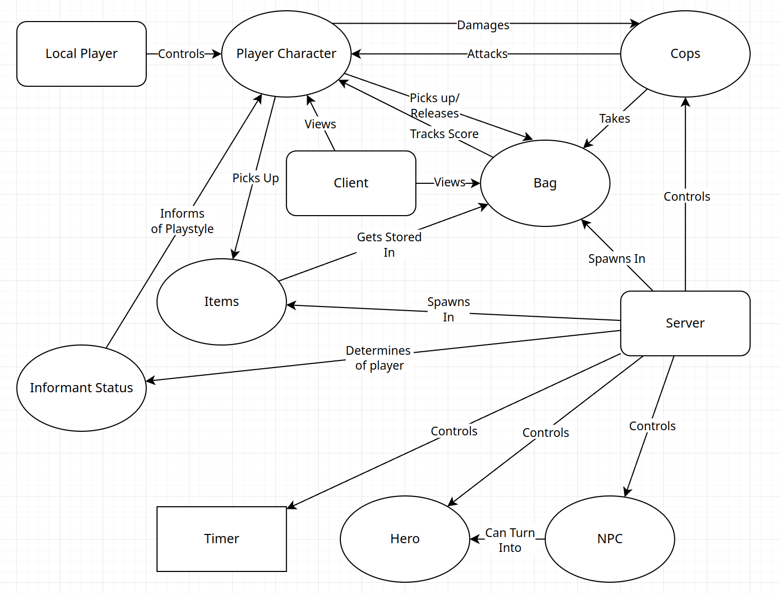

Use Case Scenarios

Requirement Fulfillment Chart

Class Relation Diagram
